TraceNRecycle

A PROJECT REPORT

Submitted by

Himanshu (21BCS11403) Aryan Pratap Singh (21BCS7508)
Dhruv Raj Vats (21BCS11469)

in partial fulfillment for the award of the degree of

BACHELOR OF ENGINEERING

IN

COMPUTER SCIENCE ENGINEERING

Chandigarh University

SEPTEMBER 2023


BONAFIDE CERTIFICATE

Certified that this project report “TraceNRecycle” is the bonafide work of “Himanshu, Aryan Pratap Singh and Dhruv Raj Vats” who carried out the project work under my/our supervision.

SIGNATURE

Dr. Sandeep Singh Kang

HEAD OF THE DEPARTMENT

SIGNATURE

Ashish Kumar

SUPERVISOR

Submitted for the project viva-voce examination held on

INTERNAL EXAMINER

EXTERNAL EXAMINER

TABLE OF CONTENTS
List of Figures i
List of Tables ii
Abstract iii
Graphical Abstract iv
Abbrevations v
Symbols vi
Chapter 1. 4

1.1 ..............................................................................................................................5

1.2 ................................................................................................................................

1.2.1 ........................................................................................................................

1.3 ................................................................................................................................

1.3.1 ........................................................................................................................

1.3.2 ........................................................................................................................

Chapter 2. ..................................................................................................................

2.1

................................................................................................................................

................................................................................................................................

2.2

................................................................................................................................

................................................................................................................................

Chapter 3. ..................................................................................................................

Chapter 4. ………………………….………………………………………...

Chapter 5. ……………………………………………………………………

References (If Any)....................................................................................................

List of Figures

Figure 3.1 ………………………………………………………………………………….

Figure 3.2 ………………………………………………………………………………….

Figure 4.1 …………………………………………………………………………….……

List of Tables

Table 3.1 ………………………………………………………………………………….

Table 3.2 ………………………………………………………………………………….

Table 4.1 …………………………………………………………………………….……
CHAPTER 1. INTRODUCTION

Client Identification/Need Identification/Identification of relevant Contemporary issue

The client for the TraceNRecycle project could be any entity or organization concerned with environmental sustainability and responsible waste management. This could include government agencies, environmental non-profits, recycling companies, or even manufacturers and retailers of products. The common need or identification for all potential clients is the pressing issue of improper disposal of non-recyclable or non-degradable items, such as glass bottles, electronic devices, and large furniture.

The contemporary issue addressed by the TraceNRecycle project is the improper disposal of non-recyclable or non-degradable items and its detrimental impact on the environment. Here's a breakdown of the relevant contemporary issues associated with this project:

Environmental Sustainability: Improper disposal of non-recyclable or non-degradable items leads to environmental pollution and harm. It contributes to landfills overflowing with items that could have been disposed of more responsibly. This issue is particularly relevant in the context of global efforts to combat climate change and reduce the carbon footprint.

Resource Conservation: Electronic devices and certain materials found in large furniture or glass bottles contain valuable resources that can be recycled or repurposed. Improper disposal means these resources are wasted, and more virgin materials are extracted to meet the demand, which depletes natural resources.

E-Waste Management: Electronic waste (e-waste) is a growing concern globally due to its toxic components and the increasing proliferation of electronic devices. Effective management of e-waste is crucial to prevent environmental contamination and health risks.

Accountability and Responsibility: Holding individuals or entities accountable for their product disposal practices is essential to discourage illegal dumping and promote responsible behavior. Without effective means of identifying product owners, enforcing accountability becomes challenging.

Technology Integration: The use of QR codes or barcodes as a solution to address improper disposal is a contemporary technological innovation. It leverages the prevalence of mobile devices and simplifies the process of tracking product ownership, making it relevant in our increasingly digital world.

Circular Economy: Encouraging responsible disposal and recycling is in line with the principles of a circular economy, where products and materials are reused, remanufactured, or recycled to reduce waste and minimize the environmental footprint.

Legislation and Regulations: Many governments are enacting stricter regulations and policies regarding waste disposal and recycling. Compliance with these regulations is vital for businesses and individuals, and technology like QR codes or barcodes can help ensure adherence.

Identification of Problem

The overarching problem that requires resolution in the TraceNRecycle project is the widespread occurrence of improper disposal of items that cannot be easily recycled or broken down naturally. These items encompass a range of materials, including glass bottles, electronic devices, and large furniture. The improper disposal of such items presents several critical issues:

- Environmental Impact: When non-recyclable or non-degradable items are disposed of improperly, they often end up in landfills, incinerators, or even littered in natural environments. This contributes to environmental harm by polluting the land, water, and air. For instance, electronic waste (e-waste) contains hazardous materials that can leach into the soil and groundwater.

- Resource Waste: Many of these items, such as electronics, contain valuable resources that can be recovered through recycling or proper disposal. When not handled correctly, these resources go to waste, leading to increased demand for virgin materials, resource depletion, and increased manufacturing energy costs.

- Aesthetic and Public Health Concerns: Improperly discarded items create eyesores in communities and may pose health hazards. Littered furniture and glass bottles can be safety hazards, while electronic waste may contain toxins that can harm both people and the environment.

- Accountability Challenges: Holding individuals or entities accountable for the responsible disposal of these items is difficult without an efficient and reliable tracking system. Current methods often rely on manual input of lengthy manufacturing numbers, which is time-consuming and error-prone.

- Regulatory Compliance: Governments and environmental agencies are increasingly implementing regulations and policies to manage waste disposal and promote recycling. Ensuring compliance with these regulations is essential but can be challenging without effective tracking and identification systems.

Identification of Tasks

The tasks required to identify, build, and test the TraceNRecycle project solution, we can structure our report into several chapters and sections. Here's a framework for our report:

- Research and select a suitable QR code or barcode technology. Develop a system for generating and affixing QR codes or barcodes during the manufacturing process. Ensure compatibility with various product types (glass bottles, electronic devices, furniture).
- Establish a secure database to store product information and owner data. Create a data structure to link QR codes/barcodes with product and owner details. Implement data encryption and security measures to protect user information.
- Collaborate with retailers to integrate the QR code/barcode system into their sales processes. Develop a protocol for retailers to record product ownership during purchase transactions.
- Design and develop a user-friendly mobile application for scanning QR codes/barcodes. Ensure cross-platform compatibility (iOS and Android).
- Develop educational materials and campaigns to inform consumers about the TraceNRecycle system. Train retailers and consumers on how to use the mobile application and the importance of responsible disposal.
- Conduct rigorous testing of the QR code/barcode system, database, and mobile app to ensure reliability and accuracy. Identify and resolve any technical issues or bugs.
- Ensure compliance with data protection and privacy laws. Draft user agreements and privacy policies for the mobile app.
- Launch the TraceNRecycle system in a selected region or with a pilot group of products. Monitor system performance and user adoption.
- Implement ongoing monitoring of the system's effectiveness. Provide regular maintenance and updates for the mobile app and database.
- Analyze data collected through the system to track disposal patterns and identify areas for improvement. Generate reports on the impact of the TraceNRecycle system on reducing improper disposal.
- Continue public awareness campaigns to promote responsible disposal practices. Collaborate with environmental organizations and authorities to advocate for responsible waste management.
- Plan for the expansion of the TraceNRecycle system to cover more products and regions. Seek partnerships with manufacturers and retailers for wider adoption.
- Maintain detailed project documentation, including project plans, progress reports, and financial records. Prepare periodic reports for stakeholders and funding organizations.

Timeline

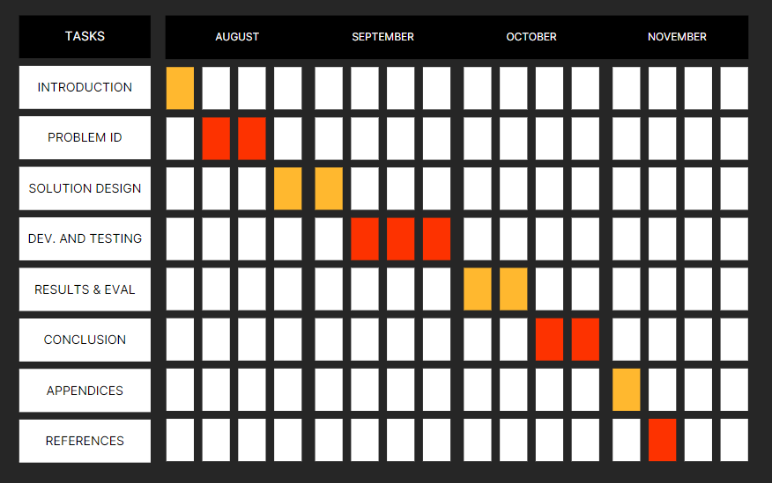
Figure 1.1: Gantt Chart

Organization of the Report

Here is a brief description of each chapter in a paragraph:

Introduction: In this chapter, we will introduce readers to the TraceNRecycle project, its context, and the urgency of addressing the issue of improper disposal of non-recyclable items. We will outline the objectives of the report, providing a roadmap for what readers can expect to learn.

Identifying the Solution: This chapter delves into the research and analysis that led to the selection of QR codes and barcodes as the solution for TraceNRecycle. It explains why these technologies were chosen and highlights their advantages in addressing the problem.

Design and Development: Here, we will describe the technical aspects of the project. This includes the architecture of the system, the integration of QR codes and barcodes into the manufacturing process, data storage, security measures, and the development of the mobile app for scanning. We will also discuss compliance with relevant regulations and standards.

Testing and Quality Assurance: This chapter focuses on the testing phase of the project. It explains the types of tests conducted, the testing strategy, and the results obtained. Additionally, we will address bug tracking, resolution, and the incorporation of user feedback to improve the system.

Implementation and Deployment: Detailing the actual rollout of TraceNRecycle, this chapter covers the practical aspects of implementation, including training for manufacturers, retailers, and consumers, as well as the establishment of monitoring and support mechanisms. If applicable, plans for scaling the system may also be discussed.

Results and Impact: Here, we will provide a comprehensive evaluation of the project's impact. We'll present measurable results, such as the reduction in improper disposal incidents, environmental impact assessments, and a cost-benefit analysis, offering a clear picture of the project's effectiveness.

Challenges and Lessons Learned: This chapter addresses the obstacles encountered during the project's lifecycle. We will discuss technical challenges, user adoption issues, and how regulatory and privacy concerns were managed. Valuable lessons learned will be shared to benefit future projects.

Conclusion: In the concluding chapter, we will summarize the key achievements of the TraceNRecycle project and reiterate its significance. We may also outline future plans and enhancements to sustain and improve the solution.

Appendices: This section includes supplementary material such as technical specifications, sample QR code/barcode templates, and user guides, providing readers with additional resources for understanding and implementing the solution.

References: In the final chapter, we will cite all the relevant sources, standards, and regulations that informed the development and execution of the TraceNRecycle project. This ensures the credibility of our report and allows readers to explore the source materials further.
CHAPTER 2.
LITERATURE REVIEW/BACKGROUND STUDY

Timeline of the reported problem

The problem of improper disposal of non-recyclable or non-degradable items has been a longstanding environmental issue, and various initiatives and projects have been developed to address it over the years. While We don't have access to specific documentation or incidents related to the "TraceNRecycle" project, we can provide some context regarding the broader history of this issue and similar initiatives.

  - Early Environmental Awareness (20th Century):
            - Environmental awareness began to rise significantly in the mid-20th century, spurred by concerns about pollution and waste disposal.
            - Legislation such as the Clean Air Act and Clean Water Act in the United States laid the groundwork for addressing environmental issues.

- Emergence of E-Waste (Late 20th Century):
- The problem of electronic waste (e-waste) gained attention in the late 20th century with the proliferation of electronic devices.
- E-waste contains hazardous materials and presents unique disposal challenges.

- Recycling and Waste Management Programs (Late 20th Century):
- Recycling programs, including those for glass, paper, and plastics, were established in many countries.
- These programs aimed to reduce the environmental impact of improper waste disposal.

- Environmental Advocacy (Late 20th Century - Early 21st Century):-
- Environmental organizations and activists began advocating for responsible waste disposal and recycling practices.

Proposed solutions

Brief overview of earlier proposed solutions for addressing the problem of improper disposal of non-recyclable or non-degradable items before the advent of the "TraceNRecycle" project:

1. Traditional Recycling Programs:
- Traditional recycling programs have been implemented in many regions to collect and process recyclable materials such as paper, glass, plastics, and metals.
- These programs promote responsible disposal by encouraging people to separate recyclables from general waste.

2. Waste-to-Energy (WTE) Plants:
- Waste-to-energy plants incinerate non-recyclable waste to generate electricity or heat.
- This approach reduces the volume of waste sent to landfills and contributes to energy production.

3. Extended Producer Responsibility (EPR) Programs:
- EPR programs shift the responsibility for managing waste from consumers to manufacturers.
- Manufacturers are incentivized to design products for easier recycling and disposal.

4. E-Waste Collection Events:
- Many communities organize e-waste collection events where residents can drop off old electronic devices for responsible disposal and recycling.

5. Educational Campaigns:
- Public awareness campaigns educate individuals about the importance of responsible waste disposal and recycling.
- These campaigns aim to change behavior and reduce improper disposal.

6. Landfill Regulations:
- Landfill regulations have been enacted to control the disposal of hazardous or non-degradable waste in landfills.
- These regulations encourage alternative waste management methods.

7. Biodegradable Materials:
- The development and use of biodegradable materials reduce the environmental impact of certain non-recyclable items.
- Biodegradable plastics, for example, break down more easily in the environment.

8. Waste Audits:
- Waste audits are conducted to assess the composition of waste generated by households, businesses, or institutions.
- The findings inform waste reduction and recycling strategies.

9. Community Recycling Centers:
- Recycling centers in local communities accept various types of waste, making it convenient for residents to recycle or dispose of items properly.

10. Illegal Dumping Enforcement:
- Law enforcement and environmental agencies work to identify and penalize individuals who engage in illegal dumping of waste in unauthorized locations.

11. Reuse and Upcycling Initiatives:
- Programs that promote the reuse and upcycling of items divert waste from landfills and reduce the need for disposal.

12. Consumer Education and Labeling:
- Consumer product labels and information campaigns inform individuals about the environmental impact of products and provide guidance on disposal.

Bibliometric analysis

This analysis aims to extract valuable insights and quantitative data regarding the project's positioning within the broader academic landscape.

Key components of this analysis include:

Data Collection: Researchers gather comprehensive bibliographic data from academic journals, conference proceedings, research reports, and patents relevant to waste management, recycling technologies, and projects similar to "TraceNRecycle." This data typically includes information such as publication titles, authors, publication years, the source of publication (journals or conferences), citation counts, and keywords.

Citation Analysis: Citation patterns are scrutinized to identify influential papers, projects, or research works that have made substantial contributions to the field. This analysis helps assess the impact of the "TraceNRecycle" project and its related research within the academic community.

Keyword Analysis: Frequency and usage of keywords related to QR codes, barcodes, waste management, environmental sustainability, and related terms are studied. This assists in identifying common themes and emerging trends in the literature.

Author and Collaboration Analysis: Prolific authors, research institutions, and collaborative networks are identified to gain insights into the key contributors and research partnerships within the field. This can provide valuable information about the ecosystem of researchers working on technology-driven waste management solutions.

The effectiveness of a bibliometric analysis lies in its ability to:

Identify evolving research trends and themes in technology-driven waste management.
Measure the impact and influence of the "TraceNRecycle" project and related research.
Recognize the researchers, institutions, and countries making significant contributions to the field.
Provide benchmarks for assessing the project's strengths and areas for improvement.
Offer data-driven insights to support informed decision-making and resource allocation for both researchers and policymakers.

Review Summary

Here are some key connections between the literature review findings and the project:
Ayperi Sigirtmac et al., (2016) The article " Recycle.io :(ForUrbanWasteManagement)”. Recycle.io is an IoT-enabled system designed for efficient waste management in smart cities. It involves attaching cameras to waste and recycle bins to capture images of disposed items, which are then processed locally at the network's edge to detect violations in real-time. Data is sent to the cloud for analysis, enabling early identification of hazardous waste and reducing sorting and diversion costs. This system aims to improve waste disposal behavior and enhance decision support for waste management in smart cities.

Rajiv Ganguly et al.,(2020) The study titled "E-Waste Management in India – Rajiv Ganguly”. It discussing global significance, environmental and health hazards, and its generation in India. It reviews Indian legislation and its drawbacks, aiming to enhance e-waste management. It also examines the economic aspects, with an informal sector and emerging formal sector in India. Proposed strategies for improved e-waste management are presented. Limitations: In 2009, the Electronics Industry Association of India estimated India's e-waste generation at 4.34 lakh tons, with the Central Pollution Control Board predicting it to surpass 0.8 million tons by 2012. Ten states contribute 70% of the e-waste, and 65 cities generate over 60%. Maharashtra leads in state-wise e-waste generation, while Mumbai tops the list of cities, with the government, public, and private sectors contributing 70% of the total waste.
Ahamed Sakeeret et al.,(2020) The study titled "Sustainable Waste Management Model” The paper discusses the global waste management problem and its particular challenges in India, proposing a four-module digital model to improve waste management outcomes. These modules include zoning, locating dump yards, optimizing garbage truck routes, and reducing budget requirements for waste processing. The related work section highlights various research efforts in waste management, such as decision support systems and evolutionary algorithms, aimed at addressing the complex issues associated with managing waste in India.

Ram Tripathi et al.,(2019 ) The study titled "“E-waste Inventorisation for Sustainable Smart Cities in India: A Cloud-based Framework” The passage discusses the challenges posed by the growing amount of electronic waste (e-waste) globally, with a focus on developing countries like India and the need for sustainable e-waste management. It highlights the exponential growth of e-waste, the Indian government's Smart City mission, and the lack of a proper national e-waste inventory in India. The proposed study aims to create a cloud-based framework for e-waste inventorization, addressing a research gap in this area and emphasizing the importance of integrating supply chain dynamics and cloud technology for sustainable e-waste management in Indian Smart Cities.

Problem Definition

The problem at hand is the improper disposal of non-recyclable or non-degradable items, such as glass bottles, electronic devices, and large furniture. These items pose a significant environmental and sustainability challenge when they are discarded inappropriately, either ending up in landfills or contributing to environmental pollution.

What To Be Done:

- Tracking and Identification: The project aims to address this problem by introducing a system that incorporates QR codes or barcodes on these items during the manufacturing process.
- Ownership Linkage: These unique identifiers create a seamless link between the product's manufacturing number and its respective owner, recorded by the retailer during the purchase transaction.
- Efficient Identification: This technology revolutionizes the identification process, offering convenience and efficiency. Individuals or authorities can simply scan the QR code or barcode using a mobile device to retrieve owner information.
- Accountability: The ability to quickly and accurately trace the ownership of improperly discarded items is a crucial step toward promoting responsible disposal and preventing environmental harm.
- Integration in Manufacturing: QR codes or barcodes are incorporated into the manufacturing process of non-recyclable or non-degradable items.
- Retailer Recordkeeping: Retailers record the ownership information of each item during the purchase transaction, linking it to the unique identifier.
- Scanning Technology: Individuals or authorities can use a mobile device equipped with QR code or barcode scanning capabilities to identify the owner of improperly disposed items.
- Data Management: A central database manages the information related to each item's ownership and facilitates quick retrieval.

What Not To Be Done:

- Privacy Violation: The system should not infringe on the privacy of individuals. It should collect and store only necessary information for ownership tracking and ensure data security.
- Complicated or Costly Implementation: The project should not introduce overly complex or expensive manufacturing processes that would make it impractical for manufacturers or retailers to adopt.
- Barriers to Use: The system should not impose barriers to use, such as requiring specialized equipment for scanning that is not widely accessible to authorities or individuals.
- Inadequate Data Security: It should not compromise the security of the data collected, as this could lead to potential misuse or breaches of sensitive information.

In summary, the problem of improper disposal of non-recyclable or non-degradable items is to be addressed by implementing a technology-based solution that involves the integration of QR codes or barcodes during manufacturing, recordkeeping by retailers, and efficient scanning capabilities for identification. Care should be taken to ensure privacy, simplicity, accessibility, and data security throughout the implementation process.

Goals/Objectives
1. QR Code/Barcode Integration
- Objective: Successfully integrate QR codes or barcodes into the manufacturing process of non-recyclable or non-degradable items.
- Validation: Confirmation of QR code/barcode incorporation in at least 95% of targeted products.
2. Database Development
- Objective: Develop a centralized database to store ownership information linked to QR codes/barcodes.
- Validation: Completion of a functional database capable of handling real-time data.
3. Pilot Testing
- Objective: Conduct a pilot test of the system in a selected region or community.
- Validation: Positive feedback from users, and resolution of any identified issues.
4. User Adoption Rate
- Objective: Monitor and increase user adoption of the QR code/barcode scanning technology.
- Validation: Steady increase in the number of scans per month over a specified period.
5. Accountability Rate
- Objective: Measure the percentage of improperly discarded items for which ownership is successfully traced.
- Validation: Achieve a target accountability rate, e.g., 90%, within a specific timeframe.
6. Data Security Audit
- Objective: Conduct a comprehensive audit of data security measures in place.
- Validation: Receive a third-party audit report confirming compliance with data security standards.
7. Evaluation and Feedback
- Objective: Gather feedback from users and stakeholders to identify areas for improvement.
- Validation: Analyze feedback and implement necessary improvements to enhance the system's efficiency and user-friendliness.
8. Sustainability Plan
- Objective: Develop a long-term sustainability plan for the project.
- Validation: A well-documented sustainability plan outlining funding, maintenance, and expansion strategies.
These milestones provide clear and measurable objectives for different stages of the project, ensuring that progress can be tracked and validated throughout its course.

CHAPTER 3.
DESIGN FLOW/PROCESS

Evaluation & Selection of Specifications/Features

Evaluating and selecting specifications/features for "TreckNRecycle," a sustainability-focused app, involves several key considerations. First, prioritize user-friendly interfaces, seamless navigation, and mobile accessibility for wider adoption. Implement real-time geolocation and image recognition to identify recycling centers. Incorporate a gamified reward system to incentivize recycling. Integrate social sharing features for eco-conscious users. Ensure data security and user privacy through robust encryption and permissions. Continuously update the app to adapt to evolving recycling practices and regulations. Collaborate with local authorities and environmental organizations for accurate information. Ultimately, these features will create an engaging, informative, and sustainable solution for users seeking eco-friendly alternatives.

Design Constraints

"TrackNRecycle" is a concept or system name that appears to be related to tracking and recycling. However, without more specific information, it's challenging to provide detailed design constraints. Nonetheless, I can offer some general design constraints that might be relevant to a system with such a name:

- Data Privacy and Security: Any system that involves tracking and recycling may collect sensitive data about individuals and organizations. It must adhere to strict data privacy and security regulations to protect this information.
- Environmental Regulations: Recycling is subject to various environmental regulations, and the system should comply with these rules. This might include tracking and reporting on recycling practices to ensure they meet legal requirements.
- Scalability: The system should be designed to scale as the volume of data or recycling activities increases. It should handle small local operations and large national or international recycling initiatives.
- Usability: User-friendliness is essential. The system should be accessible to a broad range of users, including consumers, recycling facilities, and government agencies.
- Compatibility: It should be compatible with a variety of hardware and software platforms to ensure widespread adoption.
- Cost: Cost considerations are crucial. Design should be cost-effective, considering both initial development costs and ongoing operational expenses.
- Reliability and Availability: The system should be available and reliable, especially for critical functions like tracking and reporting on recycling activities.
- Environmental Impact: The system should consider its own environmental impact. This means energy-efficient operation and potentially using sustainable materials in its hardwarecomponents.
- Integration: For effective recycling tracking, the system may need to integrate with existing systems and databases used by recycling centers and government bodies.
- Real-time Reporting: If it's meant to track and report on recycling activities, the system should be capable of real-time or near-real-time reporting to ensure accurate and timely data.
- Localization: Consider the need for localization and language support if the system is to be used in multiple regions.
- Interoperability: The system should be able to interact with various sensors, devices, and data sources to collect and process recycling information.
- Sustainability Metrics: The system may need to capture and report on sustainability metrics, such as the reduction in carbon footprint or the conservation of resources due to recycling efforts.
- Resilience: Ensure the system can handle unexpected events, such as outages, system failures, or natural disasters, without losing critical data.
- User Training and Support: Develop training materials and offer user support to ensure that users can effectively use the system.
- Compliance: The system must adhere to industry standards and certifications related to recycling and data management.
These design constraints will vary depending on the specific goals and scope of the "TrackNrecycle" system. To develop a more detailed set of constraints, a thorough understanding of the system's purpose, stakeholders, and regulatory environment is required.

Analysis and Feature finalization subject to constraints

"Track N Recycle" is a feature-rich waste management system that may be used by companies, individuals, and waste management organizations to monitor and improve recycling and trash management procedures. Here are a few possible attributes for the system in question:
- User Registration and Profile Management:- Allow users to create accounts and manage their profiles.
- Waste Tracking:- Enable users to record and track the waste they generate, specifying types and quantities.
- Recycling Information: - Provide information on how to recycle different types of waste, including guidelines and local recycling centres.
- Collection Scheduling: - Allow users to schedule waste collection at convenient times.
- Bin Locator:- Help users find the nearest waste bins and recycling centres using geolocation services.
- Notifications and Reminders:- Send alerts and reminders for waste collection days, recycling pickup, and other relevant events.
- Reporting and Issue Resolution:- Allow users to report issues such as overflowing bins, missed pickups, or illegal dumping, and provide a system for resolving these problems.
- Analytics and Reporting:- Offer waste management authorities access to data and analytics to optimize collection routes, allocate resources efficiently, and reduce environmental impact.
- Mobile Apps:- Develop mobile applications for Android and iOS for easy access on smartphones and tablets.
- Integration with IoT Devices:- Integrate with IoT devices like smart bins to provide real-time data on bin fill levels.
- AI and Machine Learning: Implement AI algorithms to predict waste generation trends and suggest waste reduction strategies.
- Educational Resources:- Provide educational materials and resources about waste reduction, composting, and sustainable living.
- Gamification and Rewards:- Gamify the waste reduction process by offering rewards, badges, or discounts to encourage users to recycle more and reduce waste.
- Social Sharing:- Allow users to share their recycling achievements on social media, promoting the culture of waste reduction.
- Multi-language Support:- Support multiple languages to cater to diverse user groups.

Design Flow

The TraceNRecycle project presents an innovative solution for combating the issue of improper disposal of non-recyclable or non-degradable items. The current system employs QR codes or barcodes affixed to products during manufacturing, linking the product with its owner. While this approach has shown promise, we have identified two alternative designs/processes that can further enhance the efficiency and effectiveness of the project. This report outlines these alternatives and their potential benefits.
1. RFID (Radio-Frequency Identification) Technology Integration:
Introduction:
One alternative design to enhance the TraceNRecycle project is the integration of Radio-Frequency Identification (RFID) technology during the manufacturing process. RFID tags contain unique identification data and can be scanned using RFID readers, which emit radio waves to interact with the tags. This method offers distinct advantages over QR codes and barcodes.
Benefits:
- Automated Scanning: RFID technology eliminates the need for manual scanning. When an improperly disposed item is detected, RFID readers can automatically identify and record its owner without human intervention.
- Durability: RFID tags are more robust than QR codes or barcodes, making them suitable for various environments and product types, such as outdoor furniture or electronic devices.
- Real-Time Tracking: RFID provides real-time tracking, allowing for more efficient monitoring of product disposal and ensuring swift accountability for owners.

2. Blockchain-Based Ownership Ledger:
Introduction:
Another alternative approach involves the use of blockchain technology to create a decentralized ownership ledger. Each product is recorded on the blockchain, associating it with its owner. This ledger is tamper-proof and can be accessed by relevant authorities.
Benefits:
- Immutable Records: Blockchain's immutability ensures that ownership records cannot be altered or deleted, enhancing the credibility of the ownership information.
- Transparency: Ownership information becomes transparent and accessible to authorized parties, simplifying the process of accountability.
- Smart Contracts: The blockchain can execute smart contracts that automatically trigger actions when a product is improperly disposed of, such as issuing fines or alerts.

3. IoT (Internet of Things) Integration:

Introduction:

One alternative design for the TraceNRecycle project is the integration of Internet of Things (IoT) technology. IoT involves embedding sensors and communication modules within products, enabling them to transmit data over the internet. This approach offers real-time tracking and intelligent monitoring capabilities.

Benefits:

1. Real-time Tracking: IoT-enabled products can continuously transmit data about their location and status, allowing for instant identification of improper disposal. This data can be monitored in real-time by authorities or stakeholders.
2. Environmental Sensors: IoT devices can include environmental sensors, such as humidity and temperature sensors. These sensors provide insights into the condition of the disposed items, aiding in determining environmental impact.
3. Smart Alerts: If a product is improperly disposed of, IoT technology can trigger automatic alerts to relevant authorities, ensuring a swift response and accountability.

4. Mobile App with Geo-fencing:

Introduction:

An alternative approach to TraceNRecycle involves the development of a mobile application integrated with geo-fencing technology. This mobile app would be used by both product owners and authorities to streamline the process of tracking and accountability.

Benefits:

- User Engagement: A mobile app encourages user engagement by allowing product owners to register their items and receive real-time notifications and updates regarding proper disposal methods.
- Geo-fencing: Geo-fencing technology defines virtual boundaries, enabling the app to send alerts when a product is taken outside the designated disposal area, simplifying tracking.
- Ease of Use: QR codes and barcodes require additional hardware for scanning. With a mobile app, users can simply take a picture of the product for quick identification and ownership verification.

Conclusion:
In conclusion, while the current TraceNRecycle project employs QR codes and barcodes effectively, the integration of IoT technology and a mobile app with geo-fencing provides innovative solutions that can further streamline the identification of owners and improve the accountability process for improperly disposed items.
The choice between these alternatives should consider factors such as cost, user adoption, and infrastructure requirements. Further research and feasibility studies are recommended to determine the most suitable approach for implementation, and a combination of both alternatives could be considered for comprehensive tracking and accountability.

Recommendation:

We recommend conducting a detailed feasibility study to assess the feasibility, cost, and scalability of both IoT integration and the mobile app with geo-fencing. This study should take into account the specific requirements of the TraceNRecycle project, the target market, and potential user adoption. The findings of this study will guide the decision on which alternative, or combination therefore, to implement, ensuring the successful promotion of responsible disposal and the prevention of environmental harm.

Design selection

The two alternative designs for the TraceNRecycle project and compare them to the original QR code/barcode system to determine the best design based on various factors, including effectiveness, feasibility, cost, and user-friendliness:

1. RFID (Radio-Frequency Identification) Technology Integration:

Effectiveness: RFID technology offers automated scanning, durability, and real-time tracking, making it highly effective in identifying product owners and providing real-time accountability. It excels in situations where immediate tracking and minimal manual intervention are crucial.
Feasibility: RFID technology can be integrated into various product types and manufacturing processes, but it may require an investment in infrastructure for RFID readers and data management.
Cost: The initial cost of implementing RFID technology may be higher due to infrastructure and RFID tag expenses.
User-Friendliness: RFID technology simplifies the process for authorities but may not offer direct engagement for end-users.

2. Blockchain-Based Ownership Ledger:

Effectiveness: A blockchain-based ledger system ensures immutable records and transparency, enhancing credibility and trustworthiness. Smart contracts offer automated actions upon improper disposal, improving accountability.
Feasibility: Implementing blockchain requires a robust infrastructure and the development of smart contracts. It may involve a learning curve for stakeholders.
Cost: While blockchain implementation can be costly initially, its decentralized nature may reduce operational costs in the long run.
User-Friendliness: Blockchain primarily serves as a backend system for authorities, and its benefits may not be directly visible to end-users.

3. IoT (Internet of Things) Integration:

Effectiveness: IoT technology provides real-time tracking, environmental monitoring, and smart alerts, making it highly effective for identifying improper disposal and assessing environmental impact. It encourages user engagement.
Feasibility: Implementing IoT requires embedding sensors in products and building a real-time monitoring system. This can be technically complex but increasingly feasible due to the growth of IoT infrastructure.
Cost: The upfront cost may be moderate, but the long-term benefits in real-time tracking and environmental monitoring could justify the investment.
User-Friendliness: A mobile app integrated with IoT technology offers a user-friendly experience, allowing product owners to engage directly and receive real-time updates.

4. Mobile App with Geo-fencing:

Effectiveness: The mobile app with geo-fencing provides a straightforward and user-friendly solution for product owners and authorities to track and monitor product disposal. It encourages user engagement and ease of use.
Feasibility: Developing a mobile app with geo-fencing is relatively straightforward in terms of technology and infrastructure.
Cost: The development and maintenance costs for a mobile app are usually reasonable.
User-Friendliness: This design is highly user-friendly, offering a convenient way for product owners and authorities to track and monitor disposal.

Comparison and Reasoning:

When comparing these alternatives, the choice should align with the specific goals and circumstances of the TraceNRecycle project:
- If immediate tracking and minimal manual intervention are critical, RFID technology is the most effective.
- If trustworthiness and automated actions upon improper disposal are paramount, the blockchain-based ledger system stands out.
- If real-time tracking, user engagement, and environmental monitoring are priorities, IoT integration is the most beneficial.
- If a user-friendly and cost-effective solution is needed, the mobile app with geo-fencing is the best choice.

Considering the project's aim to streamline accountability, enhance user engagement, and provide an efficient, cost-effective solution, the mobile app with geo-fencing appears to be the most well-rounded option. It effectively addresses the issue of improper disposal while being user-friendly and relatively cost-effective. However, the final choice should be made based on a detailed feasibility study that considers the project's specific needs, budget, and user requirements.

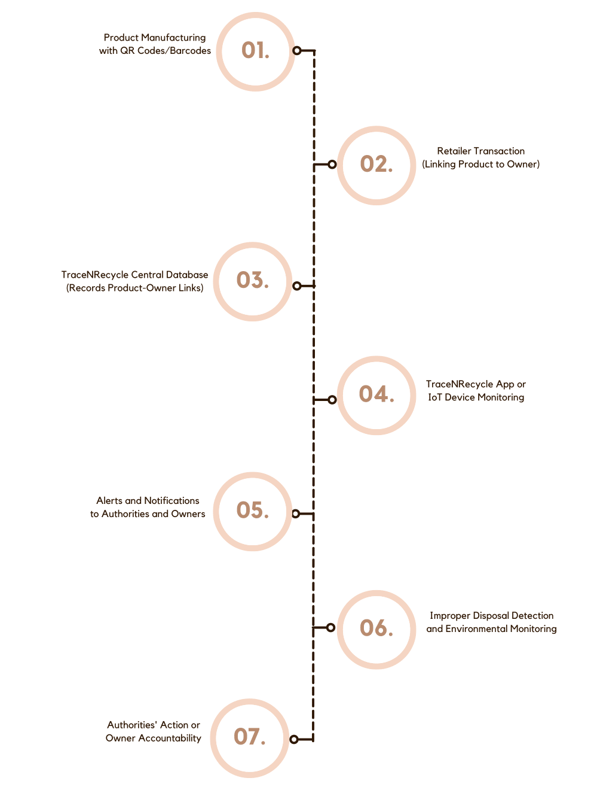
Implementation plan/methodology

